  HappyHabit  Self-Simulator Tracker | Towela Banda  design for interactice media

Design Document
Table of Content
Content
Introduction …………….……………………………………………………. 2
Evolution ………………………….………………………….……………... 2
Narrative/Experience …………………..………………………………………. 3
Storyboard ……………………………………………………..………………… 5
Scope …………………………………………………………………..………. 6
Participant Objectives ………………………………………………..………… 6
Mechanics ………………………………………………………………………. 7
Look & Feel …………………………………………………………………… 7
Overall Sketch ………………………………………………………………….. 9
Detail Sketch ………………………………………………………...…………. 9
Assets …………………………………………………………………………… 10
Schedule ………………………………………………………………………... 11

INTRODUCTION
HappyHabit is dedicated to allowing users to set, build and track their personal goals and more importantly build better habits. While also providing resources, challenges, and a community to help improve their overall well-being. The concept of this design project is a self-care tracker app that aims to help users set and achieve personal goals related to their physical, mental, and emotional wellbeing. The app provides catered and personalized enhancing resources and tools to encourage the users to take better care of themselves and their overall health. The genre of the app is health and wellness mobile application, with focus on self-care improvement. The app is designed to be used on mobile devices allowing users to access it anytime, anywhere and make progress towards their goals at their own pace. The target audience for the app is teenagers, young adults, and adults in their mid to late thirties ages 15 – 35, who are interested in improving their health and wellbeing. This demographic is high tech-savvy and is likely to use mobile applications to manage their health and wellbeing. The end product of this design process will be a fully functional prototype of the self-care tracker app including user interface design, functional and user experience. The prototype will be tested and refined based on the user feedback. The ultimate goal of the app is to help users prioritize their self-care and make positive changes in their lives to achieve greater wellness both physical and mental.
EVOLUTION
Initially, the concept for this design project was self-care simulator game, where users would select the category of their issues such as eating disorders, body dysmorphia, or depression and receive games and resource to help them overcome their challenges. However, it became apparent that self-diagnosing could lead to ethical and moral issues. Therefore, the idea was refined to develop a self-care tracker instead, where users can set daily, short-term, or long-term goals for themselves and receive customized resources to support their progress. The self-care tracker app aims to empower users to prioritize their physical, emotional, and mental health by tracking their progress towards achieving their goals. In addition to setting and tracking goals, the app will provide users with a library of helpful resources, challenges, and games to support their journey towards well-being. The primary goal of the app is to encourage users to build healthy habits, develop self-care routines, and cultivate a positive mindset towards their well-being.
NARRATIVE & EXPERIENCE
The self-care tracker app is designed to provide a supportive and engaging experience to users who want to prioritize their physical, emotional, and mental health. The app's environment is designed to be calming and relaxing, with soothing colors, minimalistic design, and clear typography to create a visually appealing interface. The app is set in the present day, where the importance of self-care and mental health has become a priority for many people. The user experience is designed to be intuitive and easy to navigate, with simple and clear instructions on how to use the app's features. The app's pivotal moments are the goal setting and tracking features, which allow users to establish and monitor their progress towards self-improvement. Users can set daily, short-term, and long-term goals that align with their values and priorities. These goals can range from drinking more water to meditating for 10 minutes daily. The app's challenges feature is designed to provide users with fun and engaging ways to cultivate healthy habits. The challenges vary from week to week and range from simple tasks like going for a walk to more complex ones like cooking a healthy meal from scratch. Users can earn rewards for completing challenges, which will help them to stay motivated and engaged. The self-care tracker app's emotional goals are to help users feel more confident and empowered in their ability to prioritize their well-being. By tracking their progress and seeing the positive impact of their efforts, users can cultivate a sense of accomplishment and pride in their journey towards better health. Usability goals for the app include creating an intuitive and easy-to-use interface that allows users to quickly access the app's features. The app will provide clear instructions and helpful tips to ensure that users feel confident in using the app to support their self-care journey. Overall, the self-care tracker app is designed to provide an engaging and supportive experience to users who want to prioritize their well-being. The app's intuitive interface, fun challenges, and helpful resources make it an effective tool for anyone looking to cultivate healthy habits and improve their overall health and wellness.
STORYBOARD
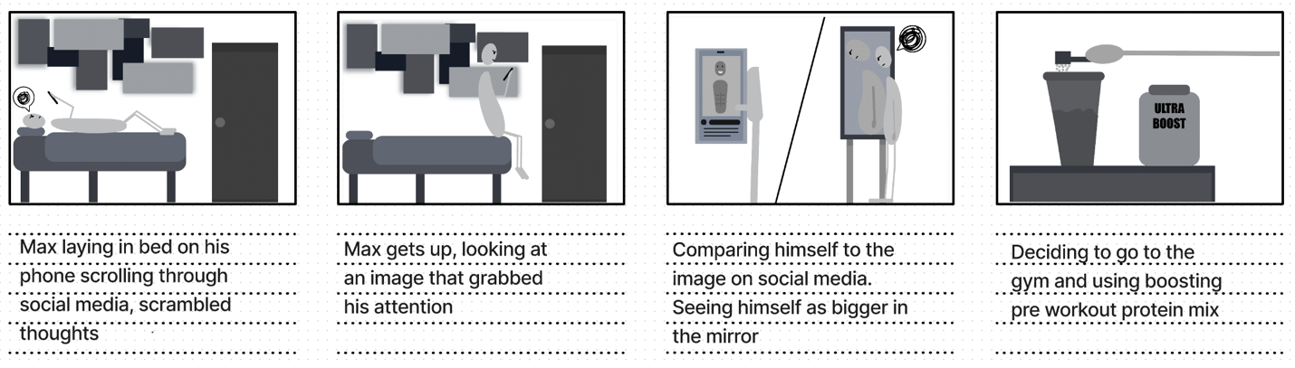
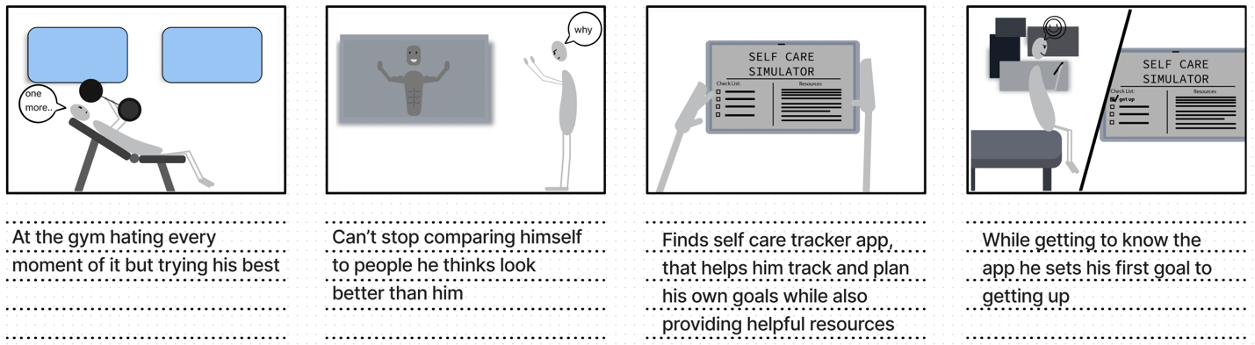
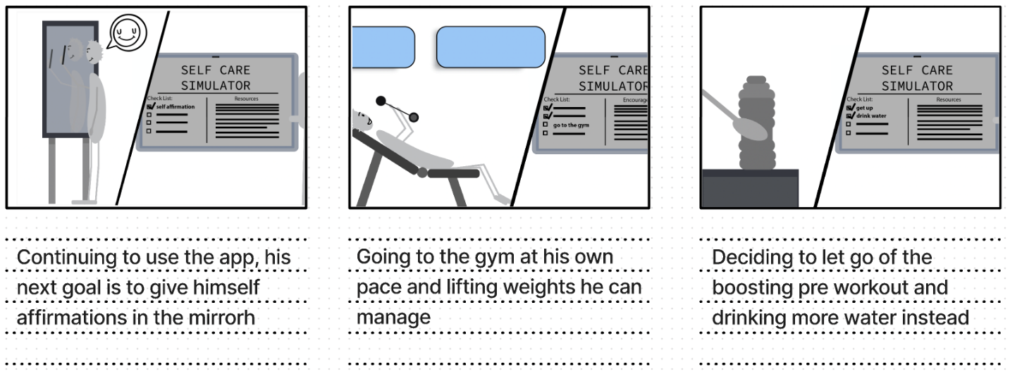

SCOPE
Design Layout/pages:
- Splash – Landing
- Signup
- Create Account
- Learn More
- Login
- Home/Main
- Helpful Habit
- Notifications
- Profile
- Dashboard
- Rewards
- Challenges
- My Community
- My Resources

PARTICIPART OBJECTIVES
Participants engaging with the HappyHabit self-care tracker will gain a tool to help them set and achieve self-care goals. By using the app, they will have access to a variety of resources and tools designed to help them improve their mental health and wellness. Participants will be able to make short, long, or daily goals for themselves, and the app will provide guidance and support to help them meet these goals. They will have access to curated resources, including articles, videos, and other self-care tools, to help them on their journey. By using HappyHabit, participants will be able to track their progress, celebrate their successes, and stay motivated to continue practicing self-care. The platform provides a supportive and non-judgmental environment for users to engage in self-care practices and improve their overall well-being.
MECHANICS
- Users can only set up to six things on their main page to make the goals or tasks more realistic and manageable.
- The user can have the option to “auto set” a goal or task, meaning that a goal or task will be automatically set for the user in the future.
- The user can set a goal or task to repeat, for example, drinking water or going for a walk.
- The user can set durations for each goal set.
- The user can set a time limit on how long they spend on the HappyHabit app.
- The user can disable/enable the challenge tab.
- The user can censor any information/topics they would not like to see on their account.
LOOK & FEEL
The art and aesthetics of HappyHabit, the self-care tracker, aim to create a soothing and inviting mood for all users. The color palette is centered around calming and mellow pastel colors, which evoke a sense of tranquility and relaxation. The chosen colors are intended to be both visually appealing and emotionally calming, providing a welcoming and non-judgmental environment for users to engage with the app. The overall aesthetic is minimalist and modern, with clean lines and simple shapes that create a sense of spaciousness and calmness. The result is an art and aesthetics that fosters a peaceful and supportive atmosphere, helping users to focus on their self-care journey.
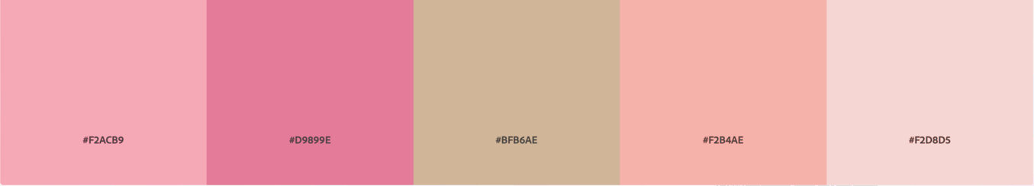
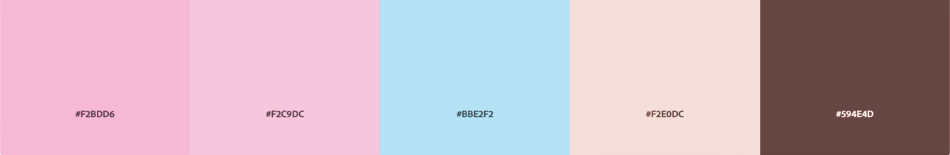
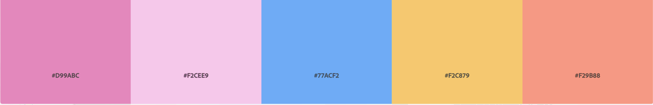

OVERALL SKETCH
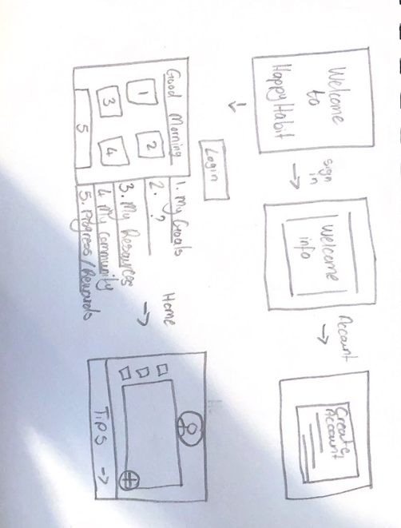

DETAIL SKETCH

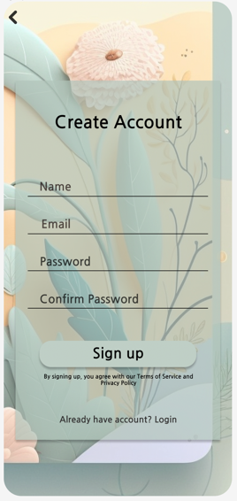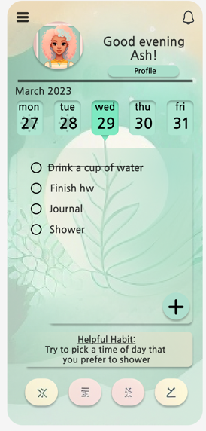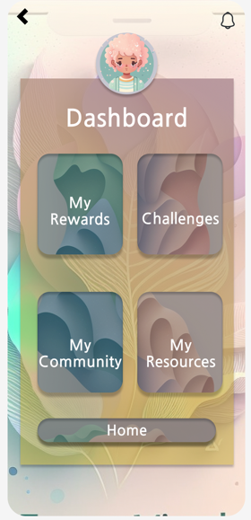
ASSETS
Design
- Logo design
- Color palette
- Typography
- Fonts
Content
- Landing page
- Main page/Home page
- Dashboard
- Resources
- Challenges
- Community
- Rewards
- Helpful Habits
User interface Design
- Figma – HappyHabit Prototype
- Backgrounds
- Graphics

SCHEDULE
Sunday | Monday | Tuesday | Wednesday | Thursday | Friday | Saturday
 |  |  |  |  |  | 1.
Revisit prototype & complete design doc/submission draft
2. | 3. | 4. | 5. | 6. | 7. | 8.
Scope down concept to manageable frame
9. | 10. | 11. | 12. | 13. | 14. | 15.
Select a frame from the design to start working on
16. | 17. | 18. | 19. | 20. | 21. | 22.
Start finalizing frame and design work
23. | 24. | 25. | 26. | 27. | 28. | 29

